How to use the Get-MFAStatus script
Pre-Setup
- Open PowerShell as Admin and run the following commands to install modules(only needs to be done once)
  - Install-Module AzureAD
  - Install-Module MSOnline
- Copy contents of Get-MFAStatus to a .ps1 file and store it locally(or in H drive)
- Open PowerShell(or PowerShell ISE) and run the following command
  - Set-Location “location to your stored script”
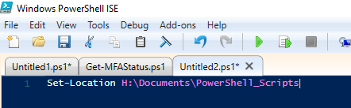

Checking User Enrollment
- Checking specific users enrollment run the following command
  - .\Get-MFAStatus.ps1 -UserPrincipalName 'user1@mltaikins.com','user2@mltaikins.com'
  - You will be prompted to login with your admin account to the Azure service
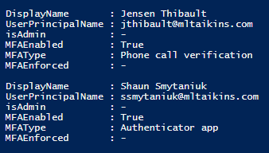
- To see all users without MFA
  - .\Get-MFAStatus.ps1 -withOutMFAOnly
- To see all admin accounts
  - .\ Get-MFAStatus -adminsOnly

